**EXPRIMENT NO-21**

**CSA1142-OBJECT ORIENTED ANALYSIS AND DESIGN**

**HOSPITAL MANAGEMENT SYSTEM**

**USE CASE**

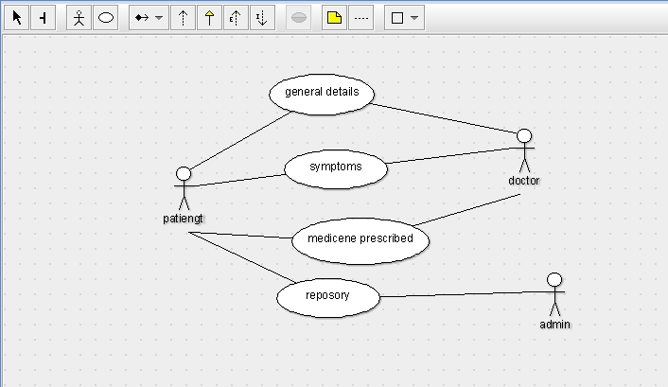

STATE DIAGRAM

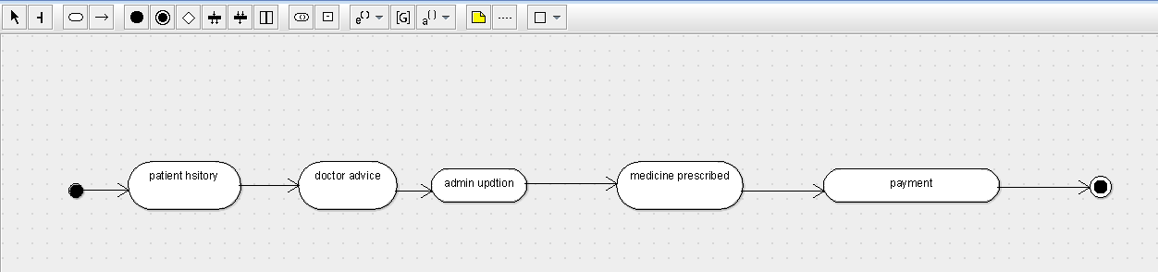

SEQUENCE DIAGRAM

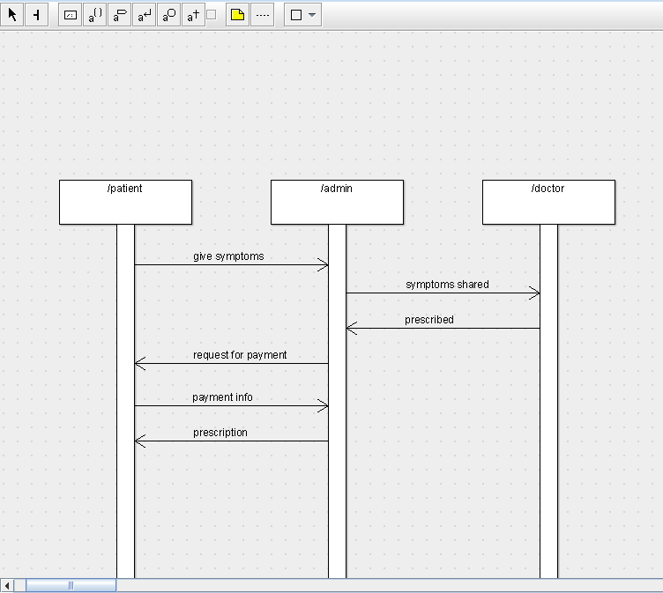

DEPLOYMENT DIAGRAM

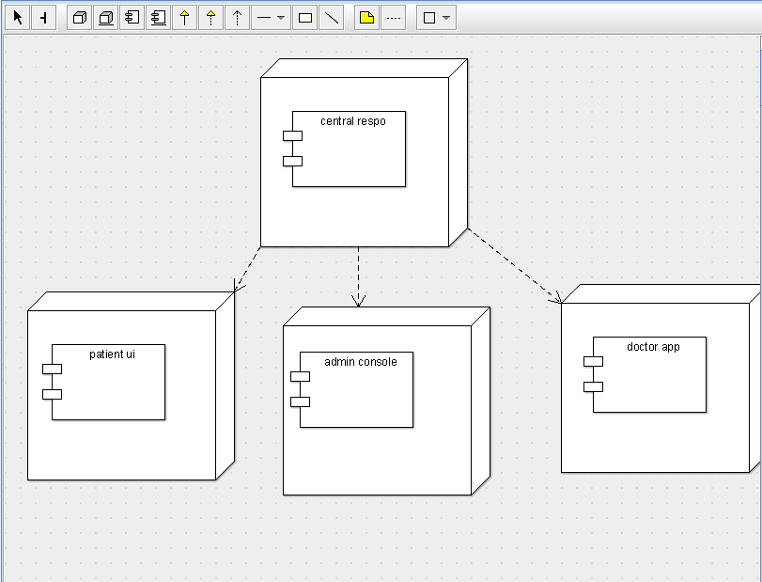

COMPONENT DIAGRAM

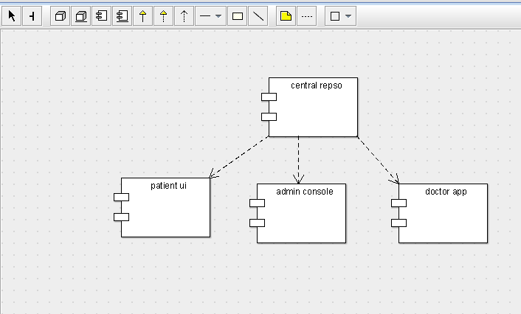

COLLABORATION DIAGRAM

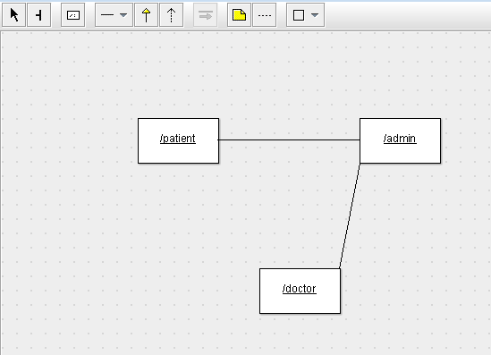

CLASS DIAGRAM

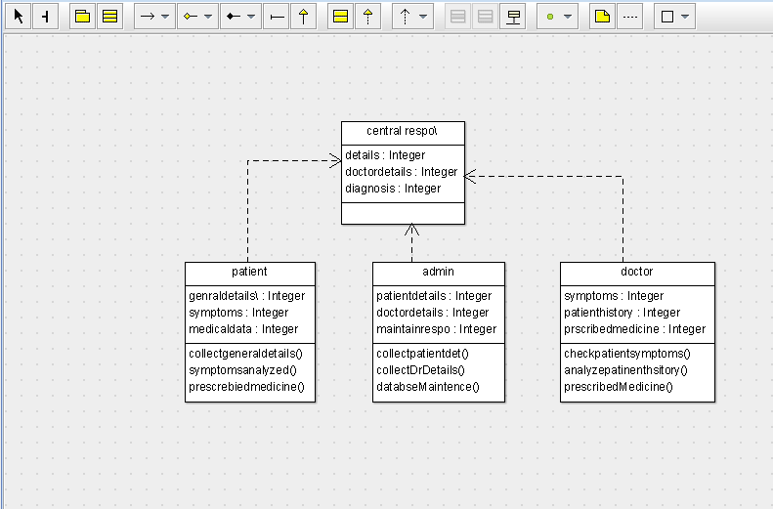

ACTIVITY DIAGRAM

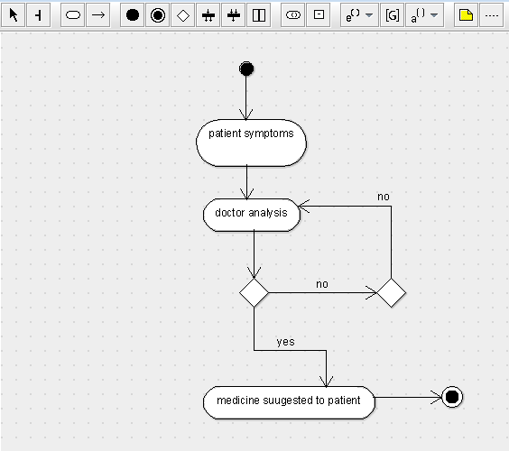

SKELETON CODE;

public class admin {

  public Integer patientdetails;

  public Integer doctordetails;

  public Integer maintainrespo;

  public void collectpatientdet() {

  }

  public void collectDrDetails() {

  }

  public void databseMaintence() {

  }

}

public class patient {

  public Integer genraldetails\;

  public Integer symptoms;

  public Integer medicaldata;

  public void collectgeneraldetails() {

  }

  public void symptomsanalyzed() {

  }

  public void prescrebiedmedicine() {

  }

}

public class doctor {

  private Integer symptoms;

  public Integer patienthistory;

  public Integer prscribedmedicine;

  public void checkpatientsymptoms() {

  }

  public void analyzepatinenthsitory() {

  }

  public void prescribedMedicine() {

  }

}